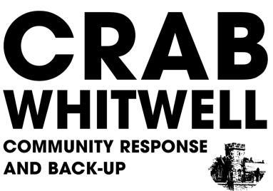

Working Group of the
NITON AND WHITWELL PARISH COUNCIL

Volunteer form

And General Data Protection Regulations (Service) Consent
to hold Contact Information

You cannot be a volunteer if you or anyone in your household is showing any symptoms of Covid19 or is currently in isolation.

If you, or anyone in your household, are in one of the risk groups (defined as the NHS advising you to have a flu jab) you can be a volunteer but we will restrict your role to non-contact, for example, you could telephone isolated people to check they are coping or be a friend by telephone or an organiser.

Are you or anyone in your household

in one of the risk groups?

Name:

Date of birth if age less than 18
Parental/Guardian Consent
for any data processing activity ……………………………………………
if volunteer age is less than 18
Address:

Contact telephone number/s:

Email:

Are there any volunteer roles that you would prefer to do?
For example:
Delivering leaflets/prescriptions
Shopping for isolated people
Being a telephone friend
Driving non-infected people to GP visits
Helping with welfare applications
Other

Are there any volunteer roles that you would prefer to avoid?

What is your availability? Times/Days?

Do you have a current DBS check?

- I have no convictions that would preclude me from volunteering in the community.
- I consent to being tested for coronavirus (if available).

- I agree that I have read and understand Niton and Whitwell Parish Council’s Privacy Notice. I agree by signing below that the CRAB Niton working group and Niton and Whitwell Parish Council may process my personal information for providing information and corresponding with me.

- I agree that Niton and Whitwell Parish Council can keep my contact information data for an undisclosed time or until I request its removal.

- I have the right to request modification on the information that you keep on record.

- I have the right to withdraw my consent and request that my details are removed from your database.

Signed:

Print:

Date:

Office use:

Clerk to the Council: Vickie Ford
Streamside
High Street
Whitwell
Ventnor
PO38 2QQ
Tel: (01983) 730806
E-mail: clerk@nitonwhitwell.org.uk

